**T01: Digital Level**

TEST PLAN

Version 1.2

Miguel Garcia, Sabin Maharjan, Christina Nelson, Calhoun Zabel

11/25/15

# Version History

|  |  |  |  |
| --- | --- | --- | --- |
| Version # | Implemented By | Revision Date | Reason |
| 1.0 | Calhoun Zabel | 11/21/15 | Initial Draft |
| 1.1 | Miguel Garcia D.L.S | 11/24/15 | Misc. |
| 1.2 | Calhoun Zabel | 11/24/15 | Those awful pictures |
|  |  |  |  |

Contents

Version History 1

1.0 INTRODUCTION 3

1.1 PURPOSE OF THIS DOCUMENT 3

2.0 REFERENCE DOCUMENTATION 3

2.1 DESIGN DOCUMENTATION 3

2.1.1 DIGITAL LEVEL BLOCK DIAGRAM 3

2.1.2 MAINBOARD SCHEMATICS 4

2.1.3 LED BOARD SCHEMATICS 6

3.0 DIGITAL LEVEL OVERVIEW 7

3.1 STANDARD OPERATION 7

3.2 TERMINOLOGY DEFINITIONS 7

3.3 COMPUTATIONAL METHODS 7

3.3.1 ANALOG TO DIGITAL CONVERSION 7

4.0 PRE-TEST INFORMATION 7

4.1 TEST EQUIPMENT 7

4.2 TEST SETUP AND CALIBRATION 8

5.0 TESTS 8

5.1 BASIC FUNCTIONALITY 8

5.1.1 BATTERY TESTING 8

5.1.2 POWER SWITCH 8

5.1.3 SUPPLY VOLTAGES 8

5.1.4 ACCELEROMETER OUTPUT 8

5.1.5 MICROCONTROLLER ANALOG TO DIGITAL CONVERSION 8

5.2 STANDARD SYSTEM FUNCTIONALITY 9

5.2.1 CORRECTLY DISPLAYS LEVEL 9

5.2.2 INCLINATION CHANGE 9

5.2.3 CORRECT AXIS 9

5.2.4 CORRECT DIRECTION 9

5.3 EXTREME/UNSUPPORTED USE CASE 9

5.3.1 UPSIDE DOWN 9

APPENDIX: TEST RECORD TEMPLATE 10

# 1.0 INTRODUCTION

## 1.1 PURPOSE OF THIS DOCUMENT

This Test Plan document outlines and documents the necessary information regarding proper testing and debugging of the Digital Level. The intended audience includes project managers and assembly and test personnel.

# 2.0 REFERENCE DOCUMENTATION

## 2.1 DESIGN DOCUMENTATION

### 2.1.1 DIGITAL LEVEL BLOCK DIAGRAM

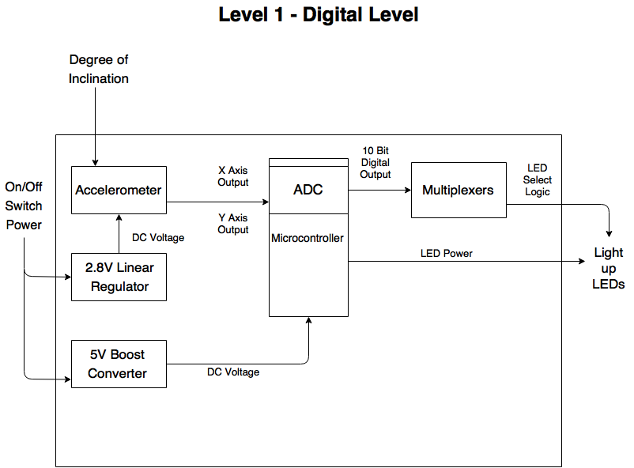

### 2.1.2 MAINBOARD SCHEMATICS

#### 2.1.2.1 2.8V LINEAR REGULATOR SCHEMATIC

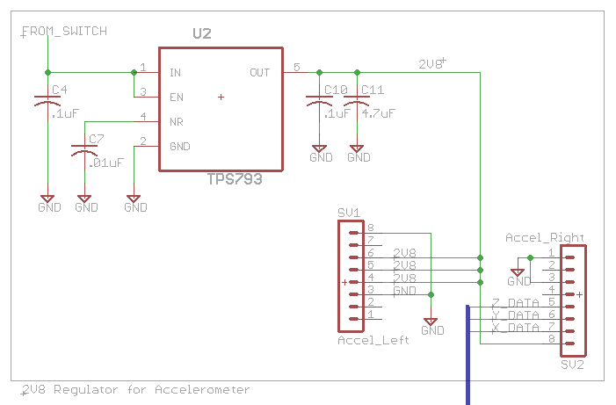

#### 2.1.2.2 5V BOOST REGULATOR SCHEMATIC

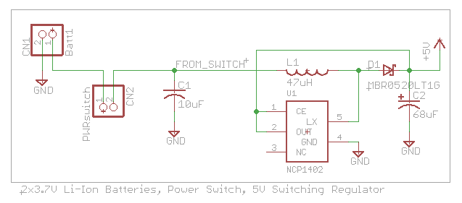

#### 2.1.2.3 MICROCONTROLLER SCHEMATIC

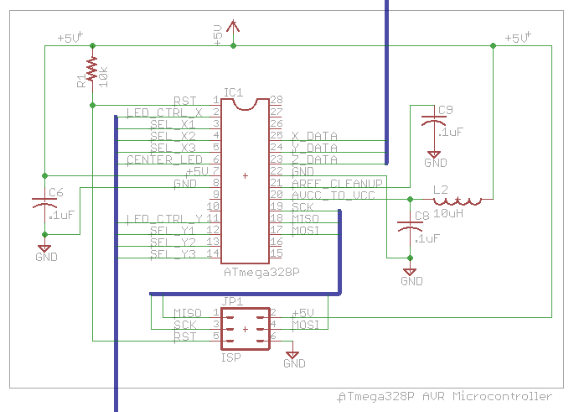

#### 2.1.2.4 MULTIPLEXING SCHEMATIC

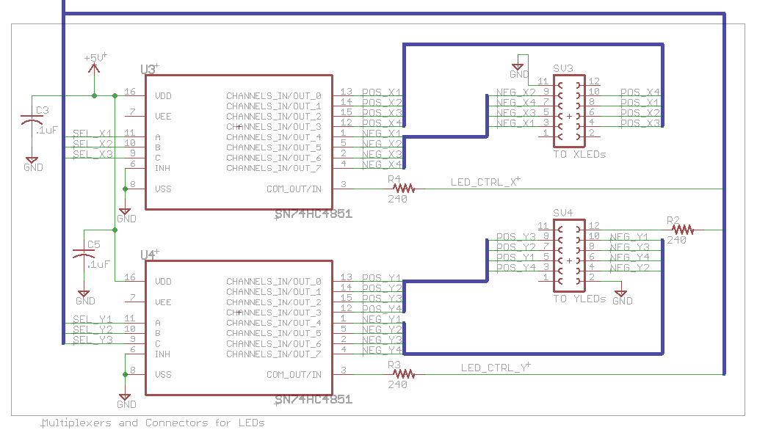

### 2.1.3 LED BOARD SCHEMATICS

#### 2.1.3.1 Y-AXIS AND CENTER LEDS

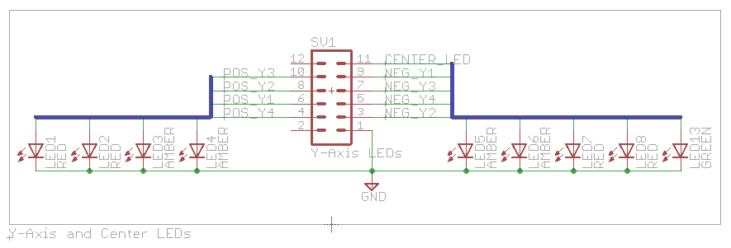

#### 2.1.3.2 X-AXIS LEDS

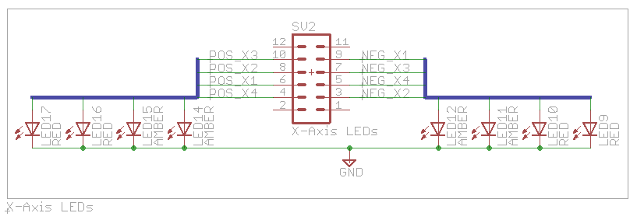

# 3.0 DIGITAL LEVEL OVERVIEW

## 3.1 STANDARD OPERATION

To use the digital level, the power switch must be toggled to the “ON” position, then the device must be placed on the surface that is to be measured. The LEDs will be illuminated to display whether or not the surface is level with accordance to its axis and magnitude.

## 3.2 TERMINOLOGY DEFINITIONS

* PCB: Printed Circuit Board
* ISP: In-System Programming
* ADC: Analog to Digital Converter

## 3.3 COMPUTATIONAL METHODS

### 3.3.1 ANALOG TO DIGITAL CONVERSION

The ATmega328P microcontroller contains a 10-bit ADC. This module of the microcontroller converts an analog input to a digital value the microcontroller can use. This value is obtained via the following equation:

$$ADC= \frac{V_{IN}*1024}{V_{REF}}$$

Where VIN is the voltage on the selected input pin, and VREF is the value of the selected voltage reference. This voltage reference can be the voltage on the AREF pin, the AVCC pin, or the internal 1.1V reference. Since the accelerometer output voltage ranges from .521 to .979V, the 1.1V reference is used to give higher precision than the other reference values.

# 4.0 PRE-TEST INFORMATION

## 4.1 TEST EQUIPMENT

* Craftsman Digital Multimeter
* Kikusui PFX2000 Battery Test System
* Standard Level
* Level surface

## 4.2 TEST SETUP AND CALIBRATION

The basic functionality tests involving the individual blocks require the use of the multimeter and the Kikusui system, while the tests involving the whole system require the standard level, and the level surface to be used. The Kikusui system is regularly calibrated by Tektronix.

# 5.0 TESTS

## 5.1 BASIC FUNCTIONALITY

### 5.1.1 BATTERY TESTING

Batteries should be connected to a Kikusui PFX2021 unit for charge/discharge information and to calculate the capacity. The profile used is configured as follows:

1. Predischarge Cycle: Constant Current (CC) discharge at .18A until battery voltage reaches 2.7V
2. Cycle 1: Constant Current-Constant Voltage (CC-CV) charge at .45A and 4.2V until battery is charged, then CC discharge at .1A until battery voltage is 2.7V
3. Cycle 2: CC-CV charge at .45A and 4.2V, CC discharge at .18A with a 2.7V cutoff
4. Cycle 3: CC-CV charge at .45A and 4.2V, CC discharge at .2A with a 2.7V cutoff
5. Cycle 4: CC-CV charge at .45A and 4.2V, CC discharge at .3A with a 2.7V cutoff

The capacity of the batteries is calculated during the discharge when they reach 3V.

If the batteries do not discharge at .18A (.2 * capacity) for more than one hour, the batteries fail this test.

### 5.1.2 POWER SWITCH

Connect power switch to correctly labeled jack on PCB and test continuity with digital multimeter. Toggle switch to “OFF” position and check resistance using the multimeter on the board. Resistance should overflow the meter (infinite resistance). Toggle switch to “ON” and test again – resistance should now be almost zero.

### 5.1.3 SUPPLY VOLTAGES

Populate PCB with components for either the 5V or 2.8V regulator, components can be found in the schematics. Connect power switch and toggle to “OFF” position. Connect battery to board. Connect leads of the multimeter to ground and any pad connected to the output of the regulator under test. Toggle power switch “ON” and ensure the correct voltage is measured at the required positions.

Repeat this procedure for the other regulator.

If the voltages do not match either 2.8V or 5V, depending on where it is measured, the device fails this test.

### 5.1.4 ACCELEROMETER OUTPUT

With the voltage regulators operational, connect the accelerometer breakout board to the main PCB. Place assembly on a level surface. Connect multimeter leads to ground and either the X or Y outputs on the accelerometer. Toggle system power “ON” and ensure the accelerometer outputs the 0-g voltage (.75V), and that it changes when the inclination of the board is changed.

If there is no voltage, if the voltage when the device is at rest is not .75V, or if the voltage does not change, the device fails this test.

### 5.1.5 MICROCONTROLLER ANALOG TO DIGITAL CONVERSION

Populate the PCB with components for the microcontroller, components can be found in the schematics. Connect ISP header from AVR Dragon to PCB in order to program microcontroller. Toggle board power to “ON.” Open Atmel Studio and load the firmware for the Digital Level. Build and begin debugging. Watch the adc_value variable to ensure it is correctly translating the analog voltage from the accelerometer.

If the adc_value does not change on each iteration of the controlling while() loop, or if the adc_value does not get a value at all, the device fails this test.

## 5.2 STANDARD SYSTEM FUNCTIONALITY

### 5.2.1 CORRECTLY DISPLAYS LEVEL

The Digital Level should be powered on and placed on a flat surface. It should be ensured that this flat surface is level by using a standard level. While the Digital Level is resting on the level surface, only the green LED should be illuminated.

If any others are illuminated, even if they are very faint, the device fails this test.

### 5.2.2 INCLINATION CHANGE

The Digital Level should be powered on and placed on a flat surface. The inclination of the device or surface should then be changed on-axis with either LED axis. Different LEDs should light up with different amounts of inclination change.

If no LEDs other than the center green LED illuminate when the inclination is changed, or if the other LEDs do not change when the device is moved, the device fails this test.

### 5.2.3 CORRECT AXIS

The Digital Level should be powered on and placed on a flat surface. The inclination of the device or surface should then be changed on one axis, parallel to one of the rows of LEDs. When the inclination is changed, the LEDs on that axis should change to indicate the changing inclination.

If the LEDs on the other axis change, and the LEDs on the correct axis do nothing – or if nothing happens on either axis, the device fails this test.

### 5.2.4 CORRECT DIRECTION

The Digital Level should be powered on and placed on a flat surface. The inclination of the device or surface should be changed relative to one axis, parallel to either row of LEDs. When one side of the device is higher than the other (farther away from the Earth), the LEDs should be illuminated on that side of the device, and not the other side.

If the LEDs are illuminated on the lower side (closer to the Earth), then the device fails this test.

## 5.3 EXTREME/UNSUPPORTED USE CASE

### 5.3.1 UPSIDE DOWN

The Digital Level should be powered on and securely fastened to the underside of a movable, flat surface. The LEDs should be pointing toward the ground in this orientation. The device should operate in the same way in this orientation as it does when it is on the top side of the surface. This means that the LEDs higher in elevation (farther away from the Earth) should be illuminated.

If the LEDs operate in an incorrect fashion, or the device does not operate at all, the device fails this test.

# APPENDIX: TEST RECORD TEMPLATE

|  |  |  |  |  |  |  |  |  |  |  |  |  |  |
| --- | --- | --- | --- | --- | --- | --- | --- | --- | --- | --- | --- | --- | --- |
| **Test Case Name:** | | Switch Functionality | | | |  | |  |  |  |  | **Test ID#:** | 01 |
| **Description:** | | Making sure power switch is functional | | | |  | |  |  |  |  |  |  |
| **Tester Information** | | | | | |  | |  |  |  |  |  |  |
| **Name of Tester:** | |  | | | |  | |  |  |  |  | **Date:** |  |
| **Hardware Version:** | | 2.0 |  |  |  | |  |  |  |  |  | **Time:** |  |
| **Setup:** | Ensure switch is toggled "off," find two pads connected to + and - of switch jack on PCB | | | | | | | | |  |  |  |  |
| **Step** | **Action** | | | | | **Expected Result** | | | | **Result** | **Comments** | | |
| **1** | Populate PCB with switch jack | | | | | N/A | | | |  |  | | |
| **2** | Plug in switch | | | | | N/A | | | |  |  | | |
| **3** | Measure resistance across connected pads | | | | | Resistance should be infinite | | | |  |  | | |
| **4** | Toggle switch "on" | | | | | N/A | | | |  |  | | |
| **5** | Measure resistance across connected pads again | | | | | Resistance should be nearly zero | | | |  |  | | |
|  |  |  |  |  |  | |  | **Overall Test Result:** | |  |  |  |  |